Week 6 - March 23rd - March 29th
“I was a stranger. You welcomed me.”
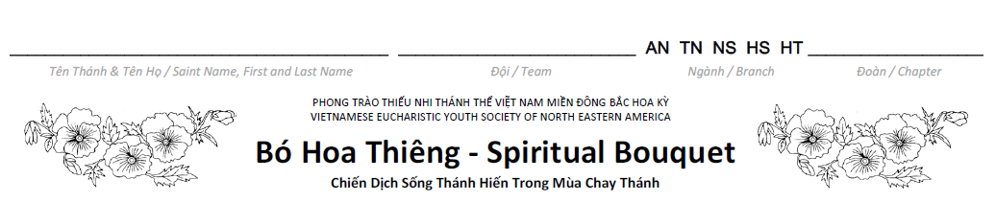

 | 23 | 24 | 25 | 26 | 27 | 28 | 29
 | Mon | Tue | Wed | Thu | Fri | Sat | Sun
Dâng Ngày ‐ Morning Prayer

Dự Lễ ‐ Attend Mass or
Rước Lễ Thiêng Liêng ‐ Spiritual Communion
Dâng Đêm ‐ Night Prayer

Hy Sinh ‐ Sacrifice (complete at least 1 act of that week)
Au Nhi & Thieu Nhi:

1. Read the Bible.
2. Refrain from using hurtful words or action against others.
3. Prayer: “God, please help those people who are being bullied. Send people to help them. Please help the people who are doing the bullying to get help so that they will not continue to hurt people. Lord, give me the courage to tell my parents about anyone I know who is being hurt or bullied.”
4. Go to confession.
5. Visit the Blessed Sacrament.
6. Almsgiving: Make a donation to your Rice Bowl. You may also ask others to participate in donating to your Rice Bowl.

Nghia Si & Hiep Si & Huynh Truong:

1. Read the Bible.
2. Fast from gossiping or listening to gossip, eat only one full meal on Friday, and abstain from meat.
3. Prayer: “God, please help those people who are being bullied. Send people to help them. Please help the people who are doing the bullying to get help so that they will not continue to hurt people. Lord, give me the courage to tell my parents about anyone I know who is being hurt or bullied.”
4. Ask God to reveal any challenges you have in the way you treat others and resolve to correct the problem by modeling your behavior after Jesus.
5. Avoid being a part of any groups that act superior to others. Make others feel welcomed in your circle of friends. Sit next to someone in the cafeteria that you don’t normally eat lunch with.
6. Allow God to use you as His tools to break down the barriers that cliques have built.
7. Go to confession.
8. Visit the Blessed Sacrament.
9. Almsgiving: Make a donation to your Rice Bowl. You may also ask others to participate in donating to your Rice Bowl.

Do at least one of the above suggested acts. Color the block on the Lenten Journey of the designated day.

