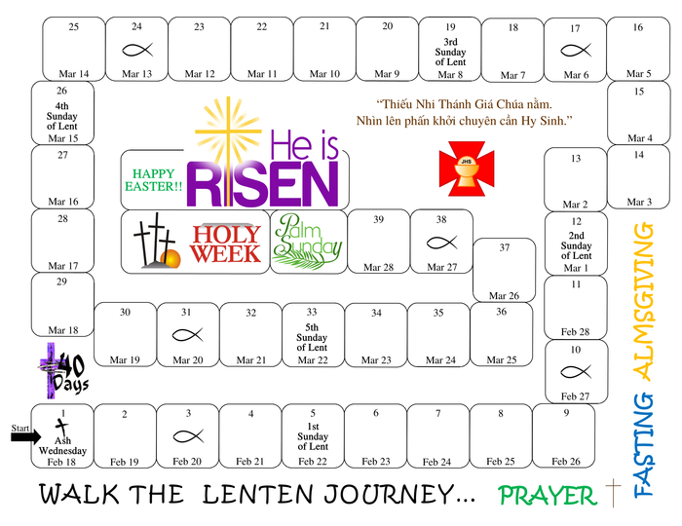
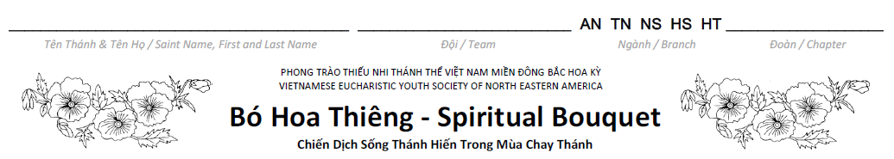

Daily Prayers Guide:  - Dâng Ngày (Morning Prayer) - Start your day with the:  - Morning Offering Prayer  - The Our Father  - Three Hail Mary  - Glory Be to the Father  - The summit of the Eucharistic Day is attending the Holy Mass and receiving Holy Communion. When unable to attend Mass and receive Communion sacramentally, receive Communion Spiritually.  - Spiritual Communion Prayer  - Lạy Chúa Giêsu Thánh Thể, con yêu mến Chúa. Xin Chúa ngự vào tâm hồn con, và ở lại với con luôn mãi. Amen.  - Dear Lord Jesus in the Eucharist, I love you and I adore you, please enter my soul and remain with me always. Amen.  - Fill the day with sacrifices and apostolic works.  - Do at least one of the above suggested acts.  - Color the block on the Lenten Journey of the designated day.  - Dâng Đêm (Night Prayer) - end your day with:  - Examination of Conscience  - Act of Contrition  - The Our Father  - Three Hail Mary  - Glory Be to the Father and the Night Offering Prayer | Instruction:  - Find a Bible.  - Make a Rice Bowl to collect donations as part of your almsgiving during this Lenten journey.  - Make a Goal for your Rice Bowl: $5, $10, $20….  - Invite your family and friends to walk the Lenten journey with you.  - Find a place in your home to place your Lenten Journey, Bible, Rice Bowl and a crayon (purple preferred).  - Do one or more of the suggested activities listed each week and color the block on the Lenten Journey of the designated day.  - Bring your Lenten Journey to the TNTT weekly meeting for your Youth-Leader to record your colored blocks. Each colored block is a spiritual flower from you to offer to Jesus.  - Donate your Rice Bowl to your chosen charity or one that your Chapter has chosen.

