Week 1 - February 18th - February 22nd
“I was in prison and you visited me.”
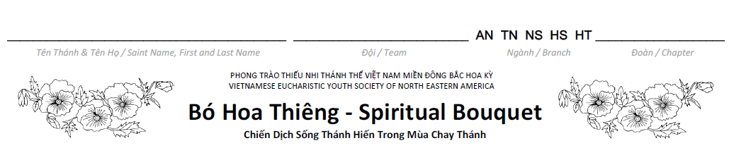

 |  |  | 18 | 19 | 20 | 21 | 22
 | Mon | Tue | Wed | Thu | Fri | Sat | Sun
Dâng Ngày ‐ Morning Prayer

Dự Lễ ‐ Attend Mass or
Rước Lễ Thiêng Liêng ‐ Spiritual Communion
Dâng Đêm ‐ Night Prayer

Hy Sinh ‐ Sacrifice (complete at least 1 act of that week)
Au Nhi & Thieu Nhi
1. Read the Bible.
2. Attend mass on Ash Wednesday.
3. Attend daily mass with intention to pray for the prisoners.
4. Fast from getting upset over small annoyances and avoid eating meat on Ash Wednesday.
5. Prayer for self-control: “Dear God, if I am upset and getting close to losing self-control or using hurtful actions instead of kind and gentle words, please remind me to ask for the help of your Holy Spirit. Amen.”
6. Prayer for prisoners: “Dear God, hear my prayers for those in prison. Give them repentance and let them believe in you. Give them patience and hope in their sufferings, and bring them home again soon. Comfort their near and dear ones. Let them trust in Jesus Christ and live with hope. Amen”.
7. Go to confession.
8. Visit the Blessed Sacrament.
9. Almsgiving: Make a donation to your Rice Bowl.

Nghia Si & Hiep Si & Huynh Truong:
1. Read the Bible.
2. Attend mass on Ash Wednesday.
3. Attend daily mass with intention to pray for the prisoners.
4. Refrain from getting upset over small annoyances and eat only one full meal and abstain from meat on Ash Wednesday.
5. Prayer for self-control: “Dear God, if I am upset and getting close to losing self-control or, using hurtful actions instead of kind and gentle words, please remind me to ask for the help of your Holy Spirit. Amen.”
6. Prayer for prisoners: “Dear God, hear my prayers for those in prison. Give them repentance and let them believe in you. Give them patience and hope in their sufferings, and bring them home again soon. Comfort their near and dear ones. Let them trust in Jesus Christ and live with hope. Amen”.
7. Go to confession.
8. Visit the Blessed Sacrament.
9. Ask God to help you make peace or forgive with those who offended you.
10. Almsgiving: Make a donation to your Rice Bowl.

Do at least one of the above suggested acts. Color the block on the Lenten Journey of the designated day.

Week 2 - February 23rd - March 1st
“I was hungry. You gave me food.”

 | 23 | 24 | 25 | 26 | 27 | 28 | 1
 | Mon | Tue | Wed | Thu | Fri | Sat | Sun
Dâng Ngày ‐ Morning Prayer

Dự Lễ ‐ Attend Mass or
Rước Lễ Thiêng Liêng ‐ Spiritual Communion
Dâng Đêm ‐ Night Prayer

Hy Sinh ‐ Sacrifice (complete at least 1 act of that week)

Au Nhi & Thieu Nhi:

1. Read the Bible.
2. Fast from all candies, cookies and soft drinks. Remember, avoid eating meat on Friday.
3. Prayer for the poor: Ask your parents to tell a story of a poor family that they know. Pray one Our Father for that family.
4. Go to confession.
5. Visit the Blessed Sacrament.
6. Almsgiving: Make a donation to your Rice Bowl. You may also ask others to participate in donating to your Rice Bowl.

Nghia Si & Hiep Si & Huynh Truong:

1. Read the Bible.
2. Fast by eating only one full meal on Friday and abstain from meat. Give up all candies, cookies and soft drinks.
3. Prayer for the unfortunates: Read an article about the poor and offer one Our Father, three Hail Mary, and One Glory be to the Father for the poor.
4. Work at a Soup Kitchen or donate canned food to a local food bank/charity.
5. Help prepare a meal for your family.
6. Go to confession.
7. Visit the Blessed Sacrament.
8. Almsgiving: Make a donation to your Rice Bowl. You may also ask others to participate in donating to your Rice Bowl.

Do at least one of the above suggested acts. Color the block on the Lenten Journey of the designated day.

Week 3 - March 2nd - March 8th
“I was thirsty. You gave me drink.”

 | 2 | 3 | 4 | 5 | 6 | 7 | 8
 | Mon | Tue | Wed | Thu | Fri | Sat | Sun
Dâng Ngày ‐ Morning Prayer

Dự Lễ ‐ Attend Mass or
Rước Lễ Thiêng Liêng ‐ Spiritual Communion
Dâng Đêm ‐ Night Prayer

Hy Sinh ‐ Sacrifice (complete at least 1 act of that week)

Au Nhi & Thieu Nhi:

1. Read Bible
2. Fasting: Give up your sweet drinks. Only drink water.
3. Prayer for Africa: Pray for Africa to get more help in bringing clean water to villages for people to drink.
4. Go to confession.
5. Visit the Blessed Sacrament.
6. Almsgiving: Make a donation to your Rice Bowl. You may also ask others to participate in donating to your Rice Bowl.

Nghia Si & Hiep Si & Huynh Truong:

1. Read Bible
2. Fast by eating only one full meal and abstain from meat on Friday. Give up sweet drinks and only drink water.
3. Prayer for Africa: Pray for Africa and the vulnerable to have more resources for clean water.
4. Learn implement one way to conserve water & help your parents wash the dishes.
5. Go to confession.
6. Visit the Blessed Sacrament.
7. Almsgiving: Make a donation to your Rice Bowl. You may also ask others to participate in donating to your Rice Bowl. Consider donating any money you would have used to buy soft drinks, coffee, etc., to your Rice Bowl.

Do at least one of the above suggested acts. Color the block on the Lenten Journey of the designated day.

