Week 4 - March 9th - March 15th
“I was naked. You clothed me.”
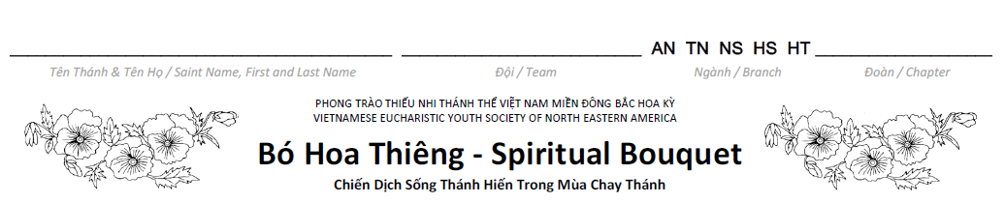

 | 9 | 10 | 11 | 12 | 13 | 14 | 15
 | Mon | Tue | Wed | Thu | Fri | Sat | Sun
Dâng Ngày ‐ Morning Prayer

Dự Lễ ‐ Attend Mass or
Rước Lễ Thiêng Liêng ‐ Spiritual Communion
Dâng Đêm ‐ Night Prayer

Hy Sinh ‐ Sacrifice (complete at least 1 act of that week)
Au Nhi & Thieu Nhi
1. Read the Bible.
2. Prayer for homeless: “Father of the poor, God of love, you made us all your children; we praise You and thank You. Full us with a sense of justice. Help us in your work, to take the side of the homeless, the struggling, the lonely, to defend the newcomer, to welcome the stranger. Help us now to befriend the friendless, protect the weak children, and work for the rights of all. Lord, on our journey home, bring us together in peace, in justice, and in love, through Christ our Lord. Amen.”
3. Refrain from playing electronic games and watching TV.
4. Clean and organize your closet. Then donate to the poor (Goodwill or Salvation Army) any new or gently used clothes that you no longer wear.
5. Go to confession.
6. Visit the Blessed Sacrament.
7. Almsgiving: Make a donation to your Rice Bowl. You may also ask others to participate in donating to your Rice Bowl.

Nghia Si & Hiep Si & Huynh Truong:
1. Read the Bible
2. Refrain from using social media, fast with only one full meal and abstain from meat on Friday.
3. Prayer: Pray for the homeless
4. Clean your room and do house chores.
5. Clean and organize your closet. Donate to the poor (Goodwill or Salvation Army) any new or gently used clothes that you no longer wear. An alternative option is to organize a clothing drive at your Chapter, church or school).
6. Go to confession.
7. Visit the Blessed Sacrament.
8. Almsgiving: Make a donation to your Rice Bowl. You may also ask others to participate in donating to your Rice Bowl.

Do at least one of the above suggested acts. Color the block on the Lenten Journey of the designated day.

Week 5 - March 16th - March 22nd
“I was ill. You comforted me.”

 | 16 | 17 | 18 | 19 | 20 | 21 | 22
 | Mon | Tue | Wed | Thu | Fri | Sat | Sun
Dâng Ngày ‐ Morning Prayer

Dự Lễ ‐ Attend Mass or
Rước Lễ Thiêng Liêng ‐ Spiritual Communion
Dâng Đêm ‐ Night Prayer

Hy Sinh ‐ Sacrifice (complete at least 1 act of that week)

Au Nhi & Thieu Nhi:

1. Read the Bible.
2. Prayer for the sick: “Father of goodness and love, hear my prayers for the sick members of our community and for
all who are in need.”
3. Refrain from teasing your siblings.
4. Call or visit your loves one (grandparents or a sick person.)
5. Go to confession.
6. Visit the Blessed Sacrament.
7. Almsgiving: Make a donation to your Rice Bowl. You may also ask others to participate in donating to your Rice Bowl.

Nghia Si & Hiep Si & Huynh Truong:

1. Read the Bible.
2. Fast by giving up your favorite food, eating only one full meal and abstaining from meat on Friday.
3. Prayer for the sick: “Father of goodness and love, hear my prayers for the sick members of our community and for
all who are in need.”
4. Call, visit, or write a card for a sick person that you know.
5. Read a story about Mother Teresa taking care of the sick.
6. Go to confession.
7. Visit the Blessed Sacrament.
8. Almsgiving: Make a donation to your Rice Bowl. You may also ask others to participate in donating to your Rice Bowl.

Do at least one of the above suggested acts. Color the block on the Lenten Journey of the designated day.

